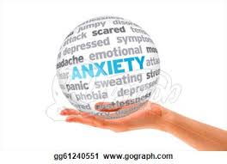

PARENTING IN THE 21ST CENTURY –
NOT THE WAY MOM AND DAD DID IT

UNDERSTANDING ANXIETY
IN YOUR KIDS

When:
- April 21st, 2016
- Refreshments at 6:00pm
- Presentation from 6:30-8:30pm

Where:
- 3000 Guildford Way, Coquitlam City Hall
- Free parking is available

Speakers:
- Ocean Van Samang - Clinical Coordinator, The START Team
- Gillian Schoenefuhs - parent with lived experience
- Dr. Lili Nasseri, MD - physician lead for CYMH in the Tricities

~ A MUST ATTEND FOR ALL PARENTS

This event is FREE but space is limited, so register early!

Register at: http://cymhsuanxiety.eventbrite.ca

This FREE speaker series is put on by the Tricities Child and Youth Mental Health Substance Use Collaborative (CYMHSU)– a partnership created by Fraser Northwest Division of Family Practice (nonprofit) and Doctors of BC.

